RFID Hall Pass – Final Project

Christopher Yang, Lautaro Stamati

Comprehensive Report

Executive Summary (Weeks 1-6):

Week 1

- This week, we entered the planning stage, which included the beginning of simulating and mapping out circuit designs using Electronic Design Animation (EDAs). Scouting for a viable option that included the specified breakout boards was the main goal.

- TinkerCAD did not offer support for the sensors and devices needed. Some open source softwares like Fritzing had lackluster support and website options were abysmal in terms of user interface. Finally, CirkitStudio met our needs, with specific boards from specific manufacturers that fit the simulation needs for this project.

- We developed a rough schematic for a circuit design, implementing a RC522 RFID Reader/Writer and an NRF24L01. Below is the CirkitStudio schematic of the prototype design.

Week 2

- It turns out that online simulation softwares did not support coding capabilities.

- We started physically constructing our circuit, and we swapped out the NRF24L01 for a ESP32 Wifi Module. Code was also developed, so right now the team has figured out how to read RFID UIDs.

- Waiting for NRF24L01’s to arrive and also waiting for more modules to be built, in order to test out the wireless communication capabilities.

Week 3

- We’ve attempted to finalize the code with four distinct versions, running all of them various times. Reading and writing strings to the RFID has been a task we haven't been able to complete, however.

- No significant changes have been made to the wiring, and code-wise we’re trying to embed a string that dictate a tag’s UID, location, and other data. When we implement 2+ devices, one device will become a “master”, redirecting all signals to its serial output, while the other devices merely detect.

Week 4

- We’ve finalized the core code across four distinct versions, testing each multiple times. While we’ve made progress, reading and writing strings to the RFID cards remains unresolved.

- The wiring has remained consistent throughout. On the code side, we're attempting to embed a string containing the tag’s UID, location, and other relevant data.

- With the multi-device setup, one device will function as the "master", redirecting all signals to its serial output, while the other devices will act as detectors only. At this point, the main development is complete — the final step is enabling communication between the cards and the system.

Week 5

- Major rework of wiring system; implementing a uniform wiring protocol over both transmitter and receiver builds. Changed the stream of information to be purely sent across the NRF24L01 wireless communication system. Both transmitter and receiver modules are identical in wiring, meaning that codes can be easily uploaded and each module can have two uses.

Week 6

- Final week, coverings and slots for card insertion have been added. The code has been finalized, changing the usage of Arduino::string into unsigned character arrays. Receiver module has slight connection issues, but nonetheless the code still transfers. NRF24L01 is extremely sensitive to any movement, so we secured the wiring inside the box with LED’s and supportive wires.

Gantt Chart & Planning:



Regards to Codes:

- Throughout the span of the project, we have had 19 official modifications to the original code, including around 2 major reworks or logic checks. The first 11 versions had only one variant, while versions 12-19 included both a receiver (rx) and transmitter (tx) variant.

Schematic, CAD, Photos:

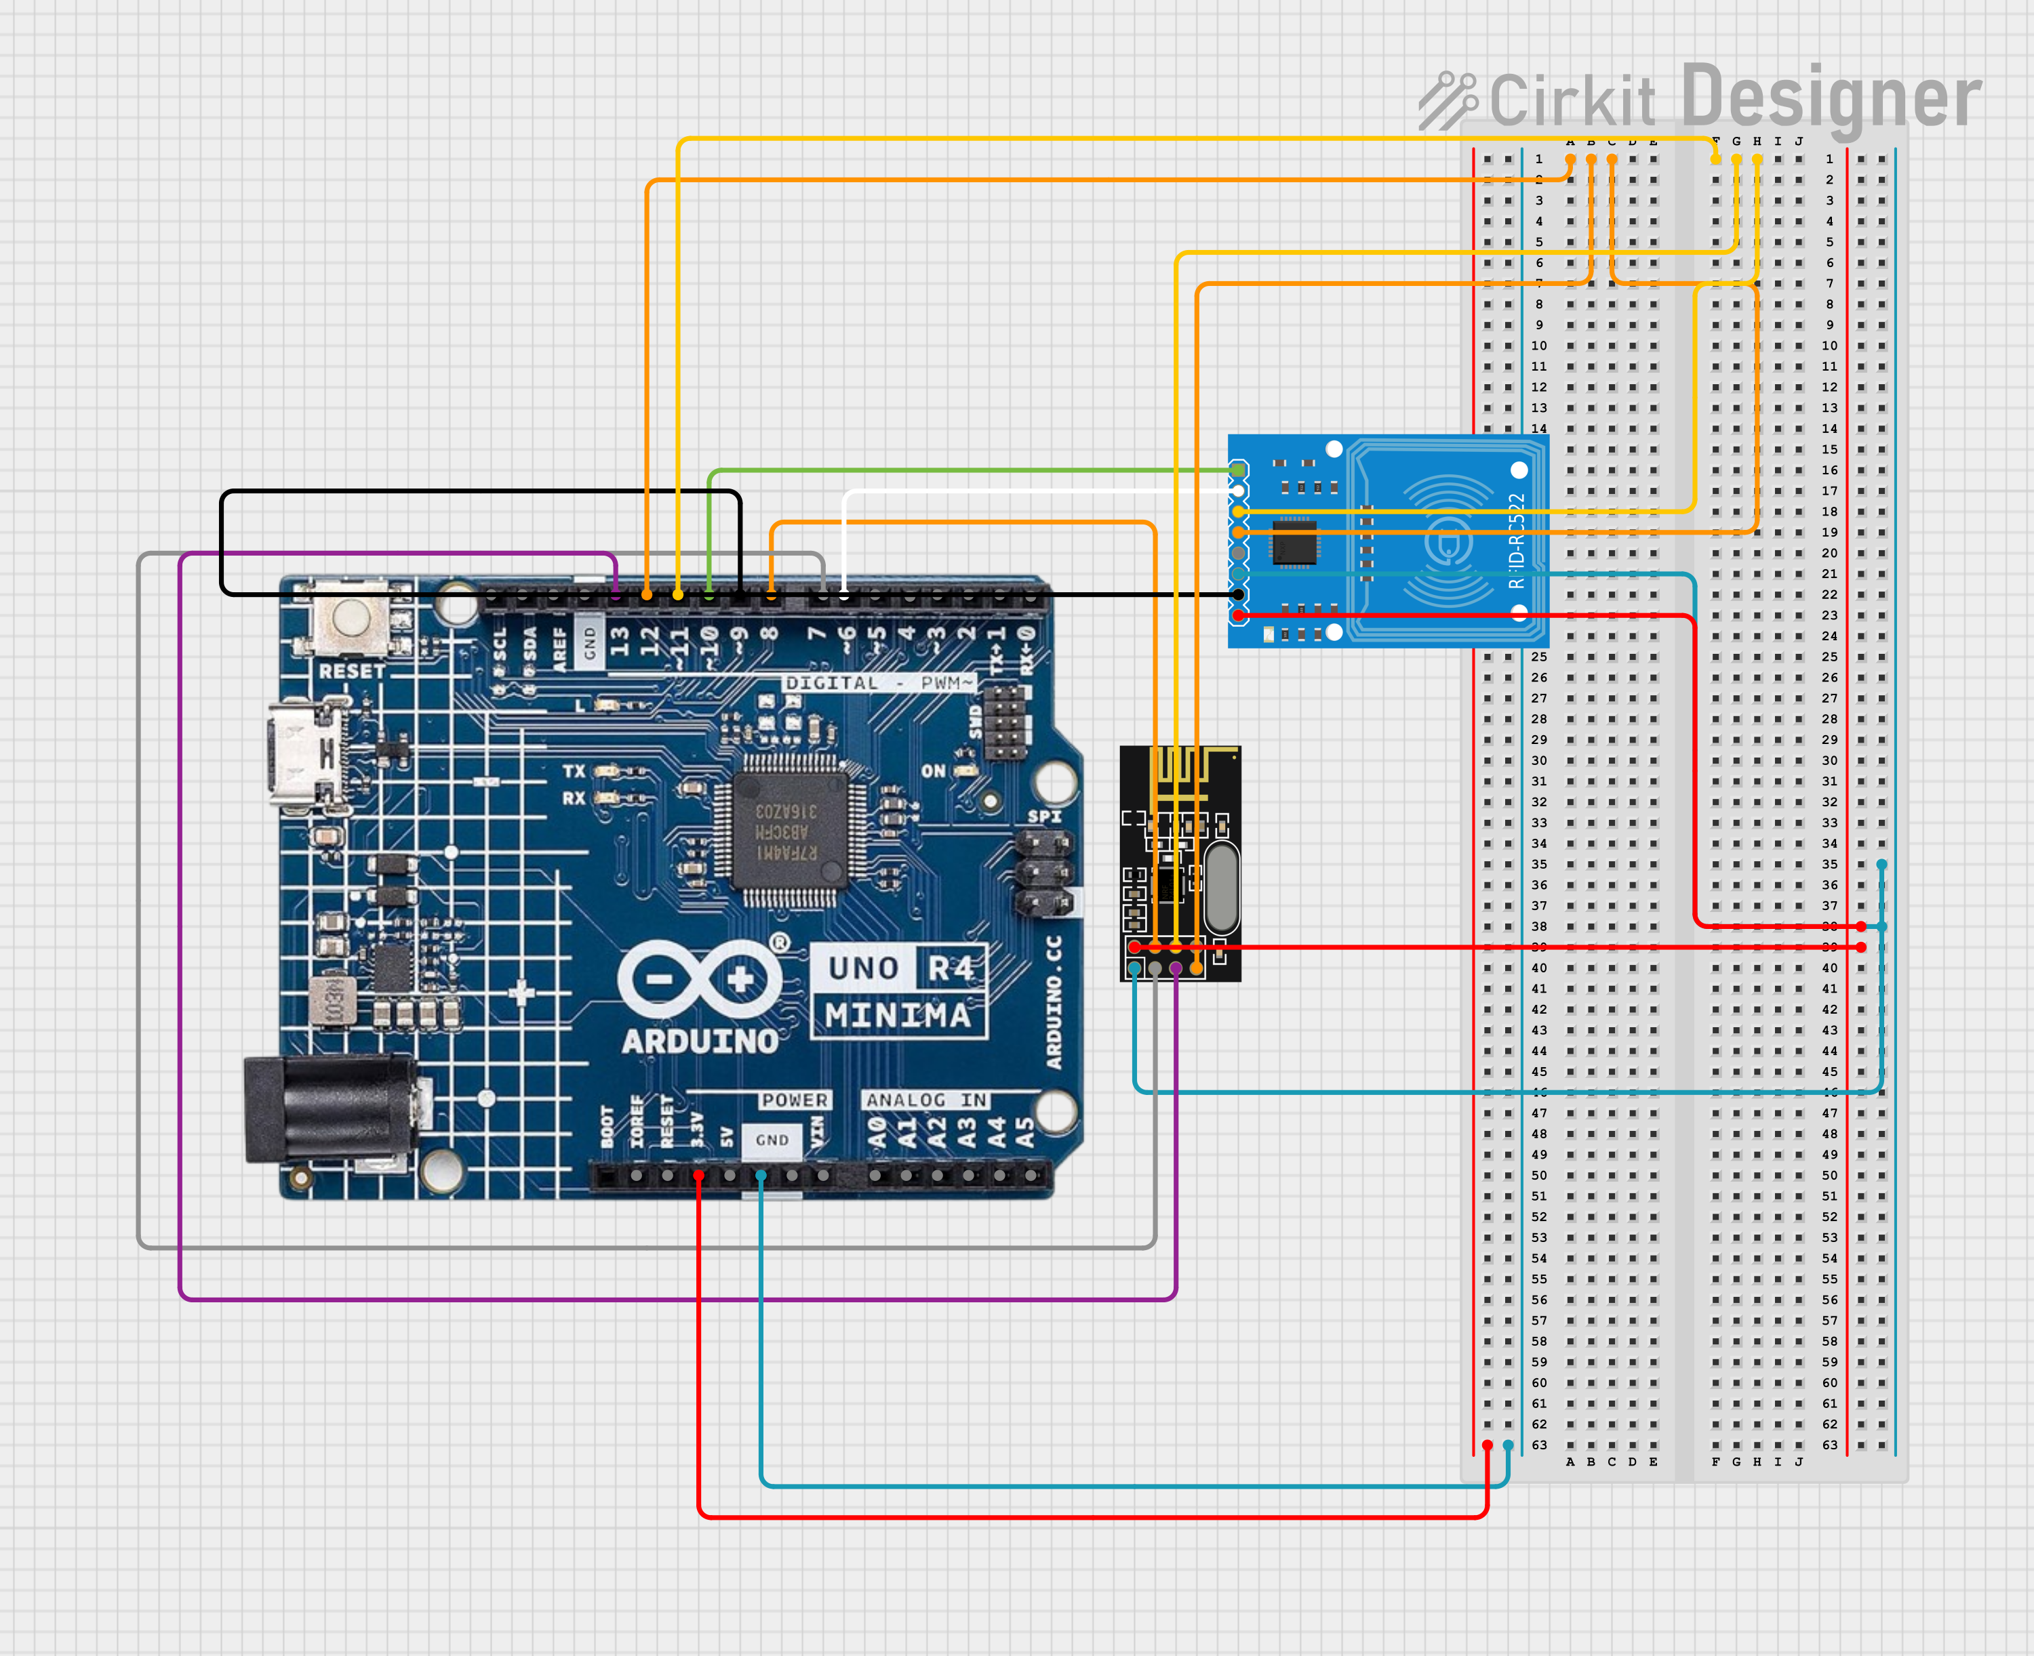

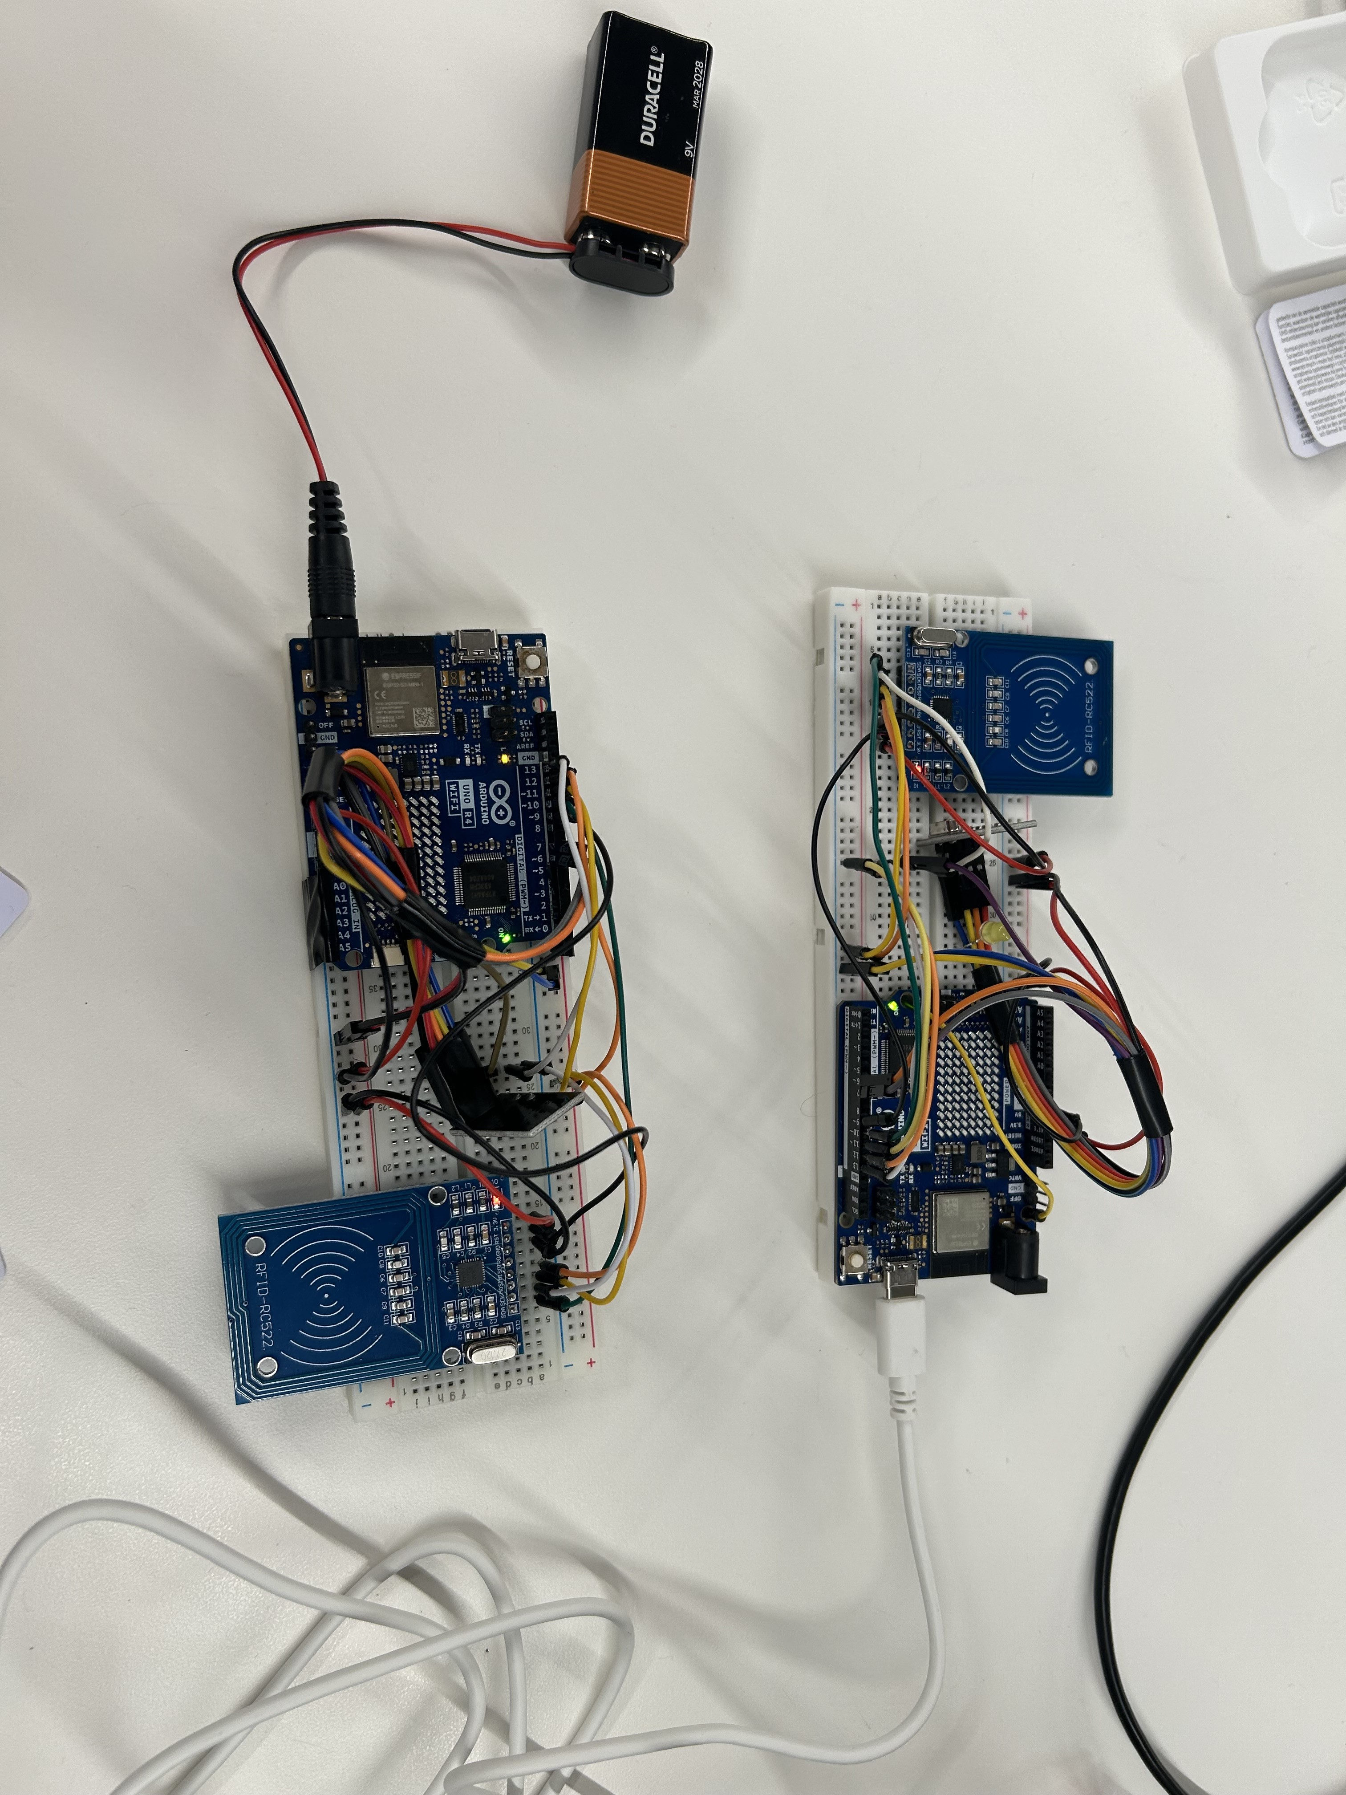

Price:

- 1x Arduino UNO (~$25)

- 1x NRF24L01 (~$1)

- 1x RC522 RFID (~$4)

- Wires (M-F, M-M) (~$5)

___________________________

Total: (~$35) per unit

Optimization can obviously be made, either with a cheaper, simpler microcontroller (like the Nano), but this is around the price for one unit. Keep in mind that for a working system, there should be at least one transmitter and one receiver.